Hello Everyone,
I hope you will find this newsletter helpful in keeping you up to date with everything that’s happening with Libraries in general and Colyton Library in particular.
Library Consultation
Your thoughts and opinions are vital. Please take part in this consultation and share it with others if you can. All the information you need is on the poster below.

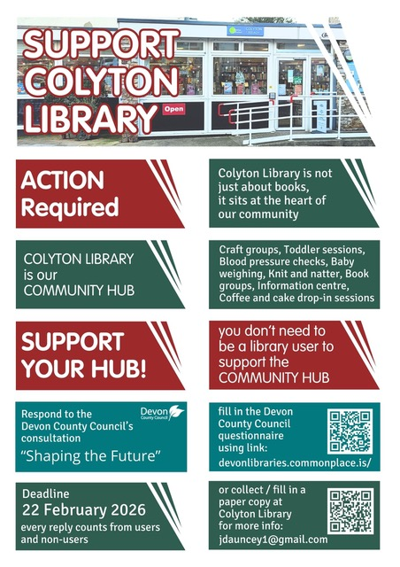

Film Screening at Colyton Library
The Ballad of Wallis Island will be screened ay Colyton Library on Wednesday 11th February. You can book in person at the Library or via Ticket Source (but you will have to pay a small charge if you do it this way).

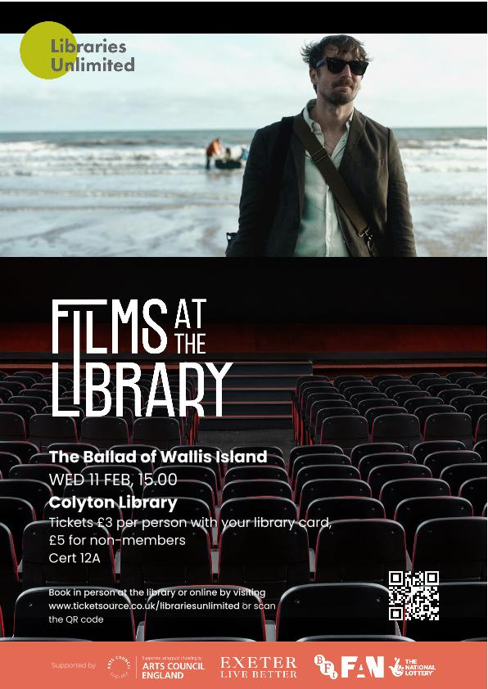

History of Colyton Library
Our Library service in Colyton is 101 years old in 2026, and Colyton Parish History Society will be hosting a talk by William Mearns, from our library service, Libraries Unlimited. He will be sharing his research on the 101 years of the public library service in Colyton. The talk is on Tuesday, 24 February at 2.30pm in the Town Hall.

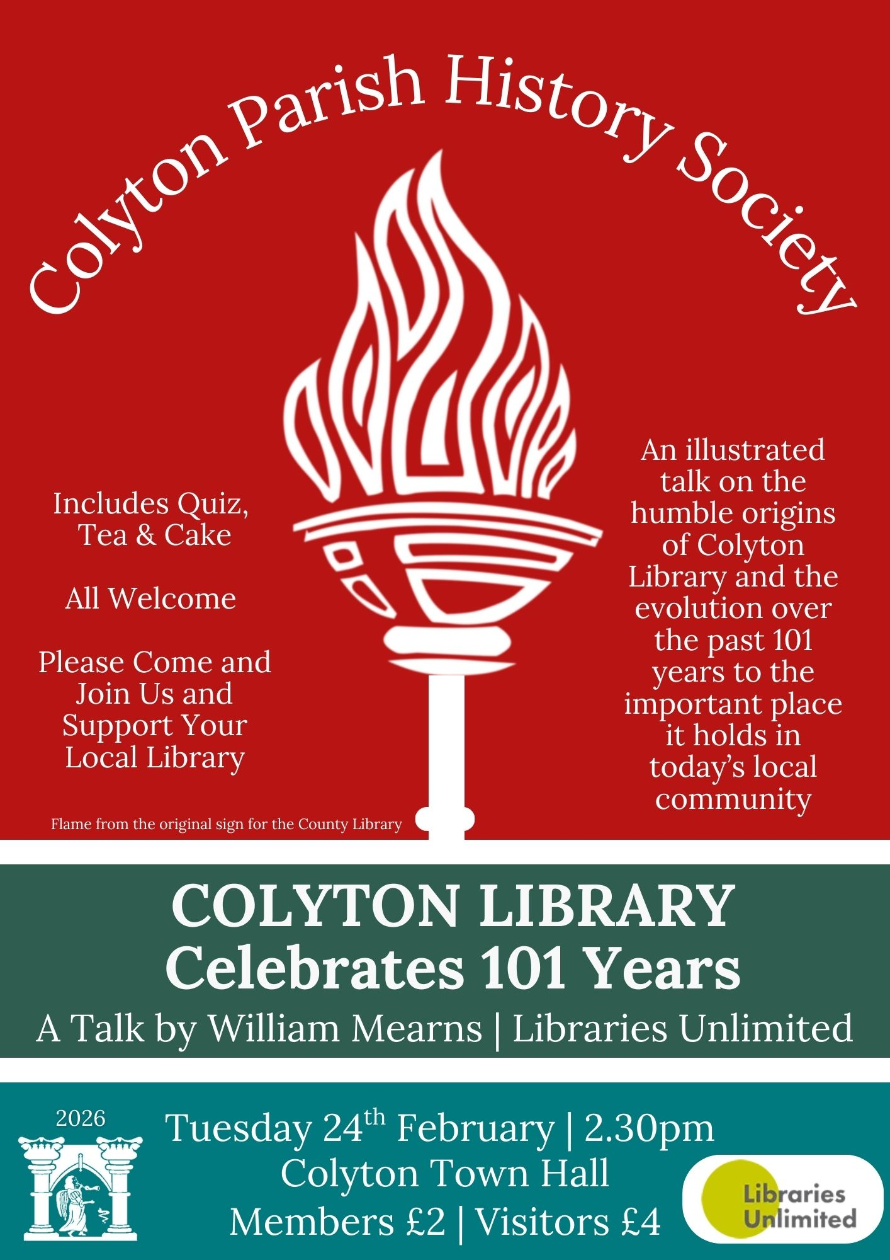

FOCL Annual General Meeting

This will be held on Monday 16th March at 2.30pm in St John Hall, Colyton. Further details and paperwork will be sent out nearer the time.

FOCL SUBS

This year the subs have increased to £7.00 per person as agreed at last year’s AGM. These are due now but can be paid in cash at the AGM on 16th March. We are no longer able to accept cheques as banking hubs and Post Offices will no longer accept them and Lloyds Bank in Seaton is closing in March.
Alternatively, if you do not already have a standing order set up, you can leave cash in a clearly marked envelope at the Library or pay via BACS. Please make sure the reference includes ‘Subs’ The account details are:
Account: Friends of Colyton Library
Sort Code: 30-90-37
Account number: 01561529

COFFEE MORNING

The next coffee morning will be held on Tuesday 3rd February 2026 from 10.30am. Tea/coffee and homemade cake only £1.50. We hope to have a visit from Paul Arnott, our local Councillor and the Leader of East Devon District Council. Come along and tell Paul how passionate we are about our Library!

